RESUME

Minna Bhavana, Email: minnabhavana6@gmail.com
Salesforce Administrator Mobile: +91 9504134134
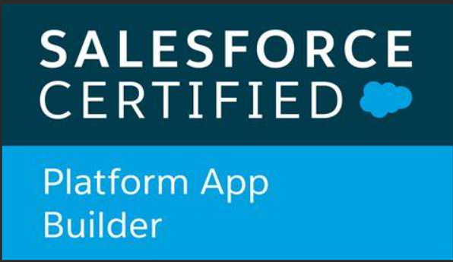
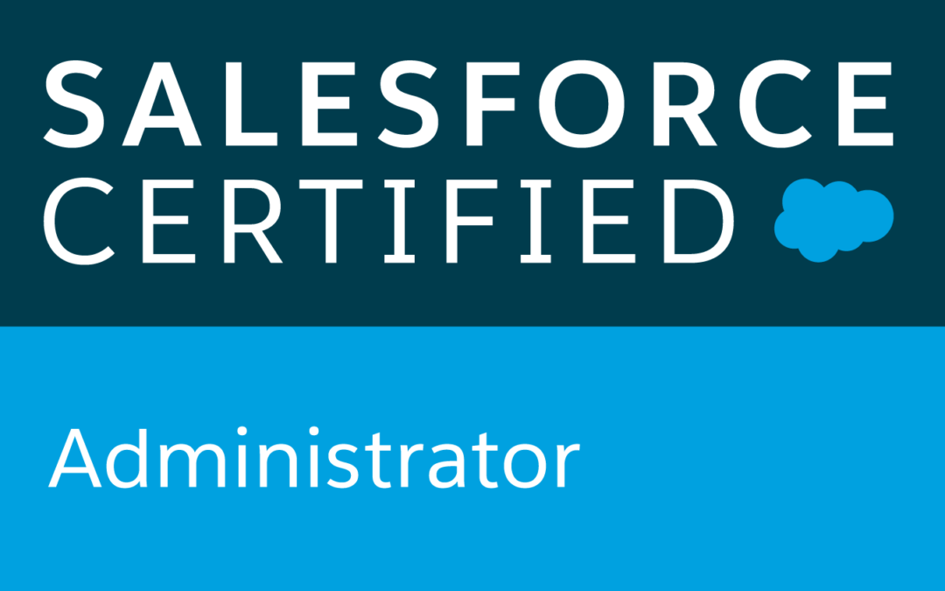
Hyderabad

Work Experience:

- An experienced and passionate Salesforce Administrator with expertise in developing, supporting projects, been working for 2+ years on Force.com platform with an overall experience of 6+ years into IT industry.
- Currently working in Vertex Computer Systems as a Software Engineer.
- Hands on experience in configuring Salesforce platform for various applications.
- Experience working in various SFDC areas covering Sales cloud, Service cloud, Lightning platform.
- Knowledge on how marketing cloud is implemented in Salesforce.
- In-depth experience in CRM business processes like Campaign, Lead, Opportunity, Account, Order, Products, Price Books and Case Management.
- Experience in handling multiple projects and responsible for quality deliver of the projects.
- Expertise in administrative tasks like creating Objects, Custom Apps, Layouts, Validation Rules, Workflows, Communities and Approval Process.
- Expertise in administrative tasks like creating and implementing flows for various business purposes.
- Experience in implementing Object-level and Record-level security using Profiles, Permission Set, OWD, Roles and Sharing Rules.
- Experience in generating Reports, dashboards and building custom report types.
- Have good knowledge on High velocity sales implementation, usage of sales cadences to increase the sales.

Technical Skills:

- Salesforce Technologies: Visual force, Sales cloud, Communities, Lightning platform
- Web Development languages: HTML5
- CRM Product: Salesforce.com
- Salesforce IDE/Tools: Apex Data Loader, Dataloader.IO.

Certification

- Salesforce Certified Administrator (SU21)
- Salesforce certified Platform App Builder (WI22)

Project Experience:
Project 1: KCED
Role: Administrator.
Description: Customer is Foreign Direct Investment in Unites states that includes nearly 500 facilities that employ almost 110,000 people. US’s low business costs, robust shipping and logistics options, a dedicated workforce and a network of state and local economic development experts and resources make it the clear choice for foreign direct investment. Customers’ international offices and available assistance are valuable assets for international companies looking to expand in the United States. In addition, customers products and services are valued by international customers. The state’s Export Initiative provides education, hands-on assistance, resources, matchmaking opportunities and grants to companies that wish to sell their products and services abroad.
Roles & Responsibilities:
- Worked on Gathering Requirements.
- Generated Monthly and Yearly reports and dashboards for analyzing the development over various stages.
- Worked on various Objects Accounts, Contacts, Lead, Case, Campaign, Reports and Dashboards.
- Created Page Layouts and Assigned to the users based on their business criteria.
- Created Validation Rules based on the business criteria.
- Created Support Processes and Record types for Cases and Other Salesforce Objects.
- Generated Web to lead and web to case forms.
- Created Approval processes and workflows to meet business requirements.
- Created multiple users, profiles and sharing rules as per the requirements.
- Tested their system based on their business requirements.
- Worked on managing multiple users, security settings and implementing chatter.

Project 2: Vertex CRM
Role: Administrator.
Description: The Company has its own salesforce instance developed to maintain all the projects they are handling, resources working for each of the project. This Salesforce instance included some of the standard objects

Roles & Responsibilities:

- Involved in gathering requirements from business user teams.
- Worked on migrating the data from Enterprise edition to essentials edition to cut down the expenditure.

- Worked on various limitations of essentials org and tried to overcome them by finding the alternate solutions.
- Worked on using the data loader to transfer the data.
- Preparation of requirements management plan, business, and functional requirement documents.
- Created data flow diagrams and process flow diagrams to facilitate better system understanding.
- Monitored new Salesforce released features and functionality to provide recommendations for process
- Reviewed requirements and technical proposals, with Time Estimation.
- Resolved incidents – Critical and Minor.

Project 3: SUMADI
Role: Salesforce Administrator
Description: This company helps organizations provide secure automated proctoring for online assessments through our AI-powered facial and typing pattern recognition, authentication, and browser tracking solutions. Vision is to modernize and simplify supervision and information validation for clients around the world in the most secure way, through a universal technology ecosystem. The only automated proctoring solution available in multiple languages, capable of being delivered concurrently at scale.
Roles & Responsibilities:

- Created user groups and configure workflows and assignment rules to enable proper routing of leads to the marketing members.
- Designed and deployed Custom tabs, validation rules, Approval Processes and Auto-Response Rules for automating business logic.
- Configured Profiles and Administrative permissions to grant/deny users access to platform features. Created Customized dashboards for the case team members to keep track of the cases assigned to them and to share insight across the company.
- Implemented pick lists, filed dependencies, lookups, master-detail relationships, validation and formula fields to the custom objects.
- Involved in preparing Business Requirement Document and Functional Requirement Document.
- Redesigned through customization and applications within salesforce.com, including the implementation of Solutions and Leads Training of salesforce.com globally for the Sales and Marketing Teams.
- Designed of a standardized Sales Process to be used by all team members in each service line and division based on Sales and Marketing preference and requirements. Create reports and dashboards for each geography within service lines based on necessary analytics
- Used Flows wherever required to automate the business processes in place of workflows and Process builders.

Achievements

- Got appreciation from the client and got best employee award. Also received multiple awards from the organization.

Work Experience Details:

- Having 5+ years of experience into IT Industry working as a Software Engineer at Tech Mahindra, Hyderabad (Sep,2015 – Feb,2021).
- Having 1 year of experience Working as Software Engineer at Vertex Computer Systems, Hyderabad (March,2021-March,2022)

Education Details:

- B. Tech (ECE) from R.M.K Engineering College with 76.7% aggregate.
- Board of Intermediate Education from Chaitanya Educational institutions with 89.1% aggregate.
- Board of Secondary education from Gowtham Concept schools with 95% aggregate.

Place: Hyderabad Minna Bhavana

